# Assignment #3: Database-Driven Web Pages

#### Due Nov 16 2016 midnight

## Overview

This assignment provides an opportunity for you to demonstrate your ability to generate web pages from database content using PHP. You will how your understanding of CSS, HTML, AJAX and Boostrap.

## Submitting

You will be submitting a zip file with all the php files. These files will be in a zip folder named assignment3_lastname_firstname.zip.

## Grading

The grade for this assignment will be broken down as follows:

Visual Design and Styling 15%

Functionality (follows requirements) 80%

## Database

In this assignment you will be provided with a MySQL database containing information for an art store (i.e., artists, paintings, customers, sales, etc).

## Database Schema

While the database contains quite a few tables, this assignment will make use of only six tables: artists, works, genres, subjects, orders, and order details. Two linking tables are also used.

An art work has a single artist. An artist can have many art works. An order consists of many order details; each order has a single customer. An order detail has a single art work. An art work can have many subjects and genres. **You are NOT allowed to change data or table definitions!**

## Requirements

This assignment consists of 6 pages with the following functionality:

1. You must make use of the Bootstrap CSS Framework (http://getbootstrap.com/) to style and layout your pages. While this framework does have a little bit of a learning curve, you will find that it makes your life as a web developer significantly easier since you will be able to concentrate on programming and let Bootstrap handle the CSS. Look at the examples on the Bootstrap web site to help you understand how the make use of it.
2. The about page must be named about.php. This about page must specify that this site is an assignment for COMP XXXX, your name, and the date [worth 4 marks]
3. The site **must** use a single CSS file for any additional text and color formatting. [visual design worth 15 marks]
4. All pages must have six links: to Default.php, AboutUs.php, Part01_ArtistsDataList.php, Part02-ArtistDetails.php?id=19, Part03-ArtistDetails.php?id=394, Part04_Search.php pages. [worth 4 marks]
5. The home page **must** be named default.php. This home page must contain additional links to the pages as shown below:



I would also strongly recommend creating the following pages in the order provided below.

1. This page must be named Part01_ArtistsDataList.php. It must display a list of artist names (from the Artists table) that should look like that shown below. Notice the sort order. Each artist should also be a hyperlink to Part02_SingleArtist.php with a query string parameter id which is equal to the id of the artist. [worth 8 marks]

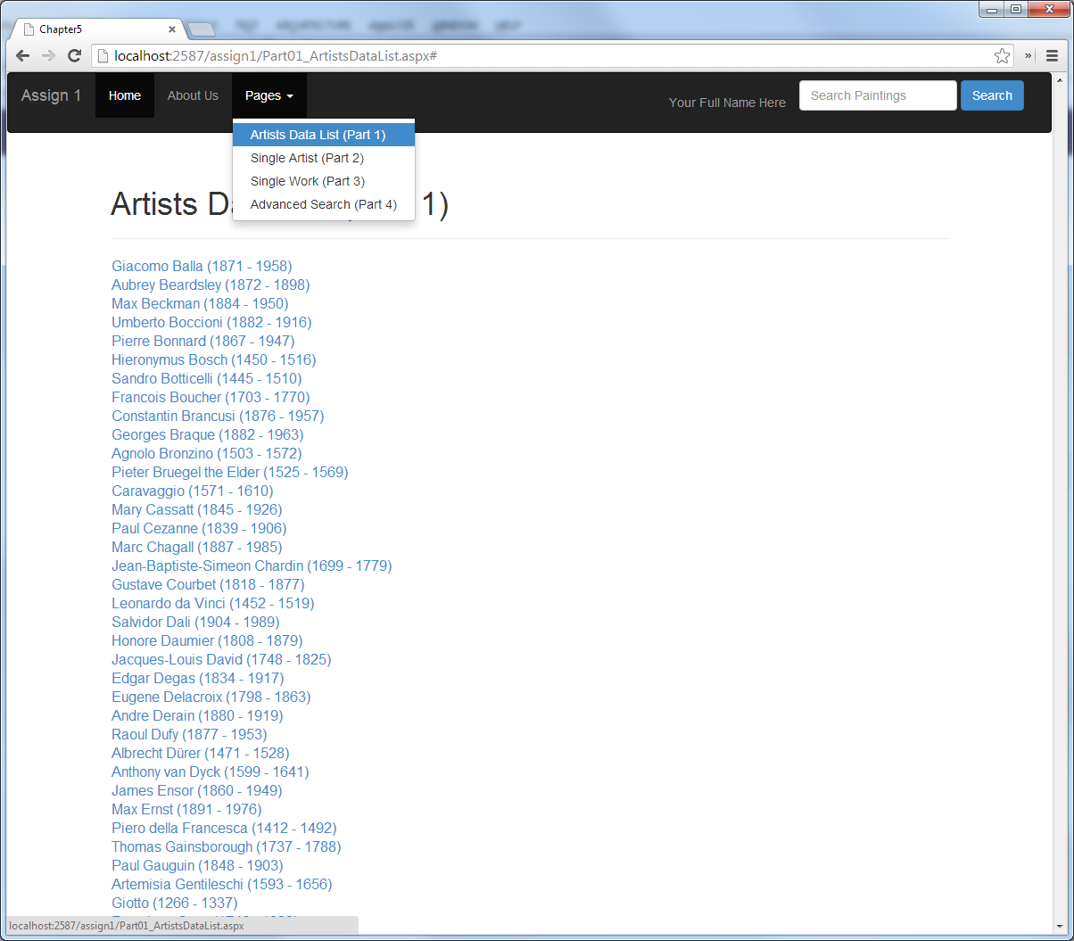

1. This page must be named Part02_SingleArtist.php. This page displays information from the Albums and Artists tables for a single artist (specified via the artist id passed in via a query string parameter). You must use display the artist information. This page should handle a missing or invalid query string id parameters by redirecting to a page called Error.php. Use the Bootstrap Thumbnail class. The work’s thumbnail, title, and the View button must be links for that work to Part03_SingleWork.php). [worth 17 marks]

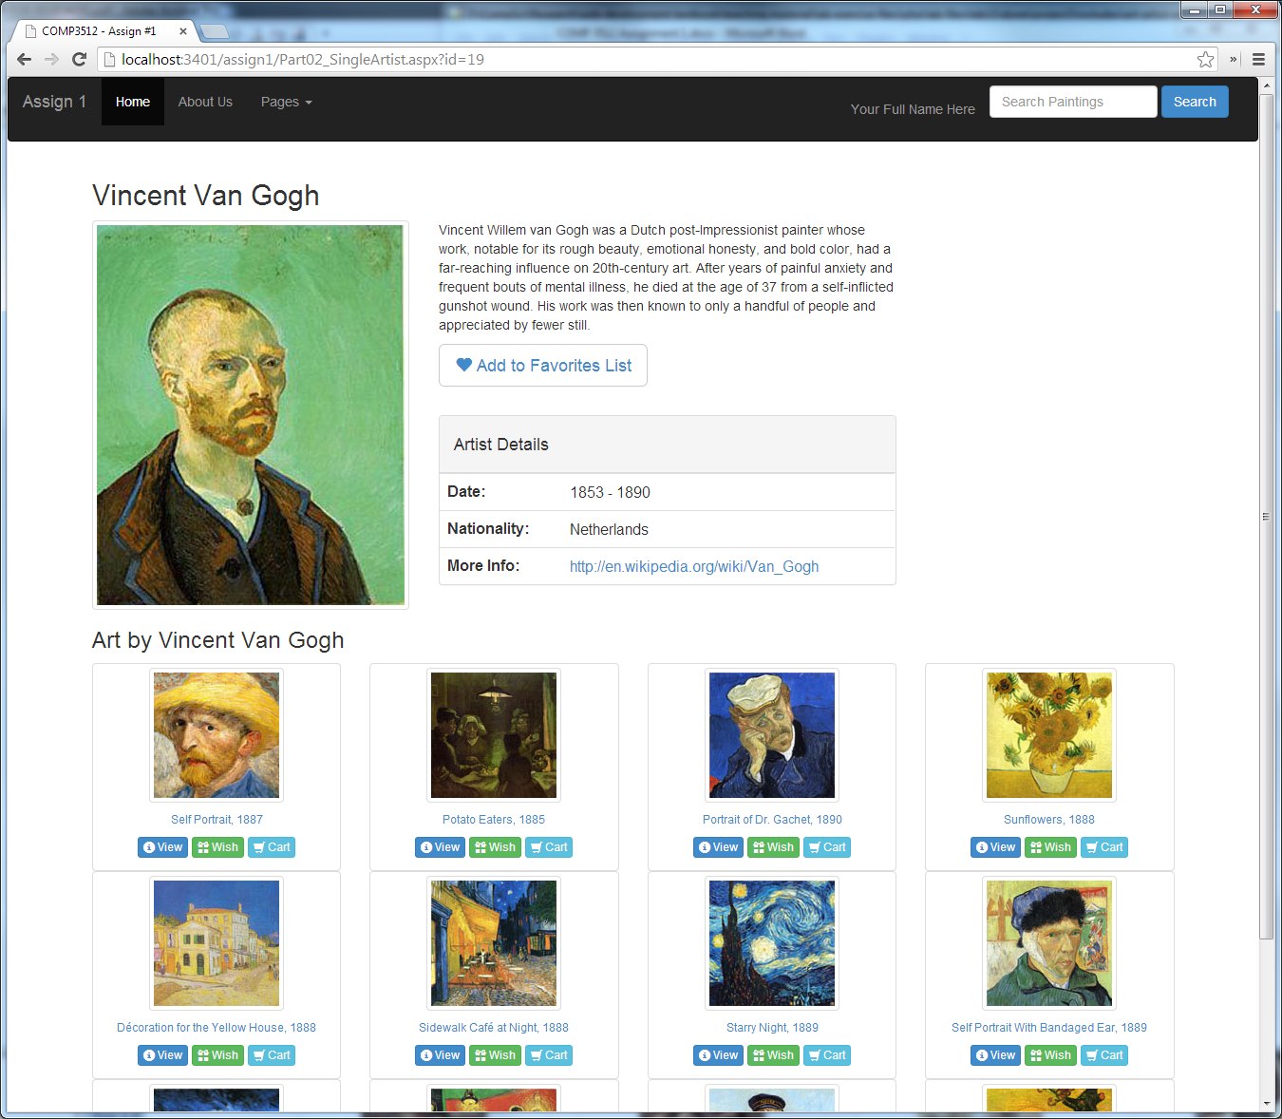

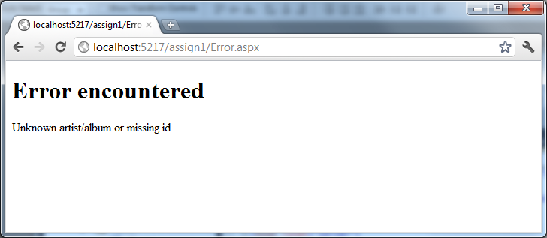

1. This page must be named Part03_SingleWork.php. This page displays information from the Works and Artists tables for a single work (specified via the art work id passed in via a query string parameter). You must display the painting information (hint: remember that SQL allows you to join information from multiple tables). The artist name must be a link to Part02_SingleArtist.php for that artist. Notice that you must also display genres and subjects for the requested art work, as well as any orders for the requested art work.   
     
   The image must be a link to the large version. Use the Bootstrap Modal dialog (in Javascript section of documentation) to display the larger version.

Like with Part02_SingleArtist.php this page should handle a missing or invalid querystring id parameter. [worth 22 marks]



1. This page must be named Part04_Search.php. It must display art work information (from the ArtWork table) that should look like that shown below. If the page is requested via a link, it should at first display only the filtering criteria. Notice that you will have to hide/show textboxes depending upon the state of the radio buttons. If the user has typed in a value in the search box in the header on any page, then it should redirect to this page using a query string, and perform a filter by Title for the query string value.   
     
   Both title and description searches should use the SQL LIKE operator with wildcards so that it matches any occurrence of the search string. When the user presses the Filter button, then display the square art work image, the title, and the description for any matching art works. The title and image must be a link to Part03_SingleWork.php for that art work.  
     
   If user does a filter by description, then highlight in yellow the search field in the resulting description. [worth 30 marks]



Preliminary Marking Guide Assignment #1

|  |  |  |  |
| --- | --- | --- | --- |
| / 15 |  | **Visual Design and Styling**   - Text and Color Formatting + CSS usage + consistency  - Used Bootstrap appropriately   - Layout accurate Part01  - Layout accurate Part02  - Layout accurate Part03  - Layout accurate Part04  - Layout accurate Part05 | |
| / 8 |  | **Home and About Page**   - links + appropriate content  - link to home page on each page | |
| / 8 |  | **Part01_ArtistsDataListWithLinks.php**  - hyperlink with proper querystring id | |
| / 17 |  | **Part02_SingleArtist.php**  - Data control + correct album data   - data + links  - handle querystring errors  - show art work for artist with appropriate links | |
| / 22 |  | **Part03_SingleWork.php**  - correct art work, artist, order, subject, and genre data   - handle querystring errors  - Use modal dialog to show larger image | |
| / 30 |  | **Part04_Search**  - Data controls  - Filtering  - hide/show fields  - highlight search term in description   - Proper data  - search in header works on all pages | |
| / 100 |  | Total Mark |